CVMC PRODUCTION CAR AUTOTEST - SUNDAY 23rd JULY 2023
SUPPLEMENTARY REGULATIONS

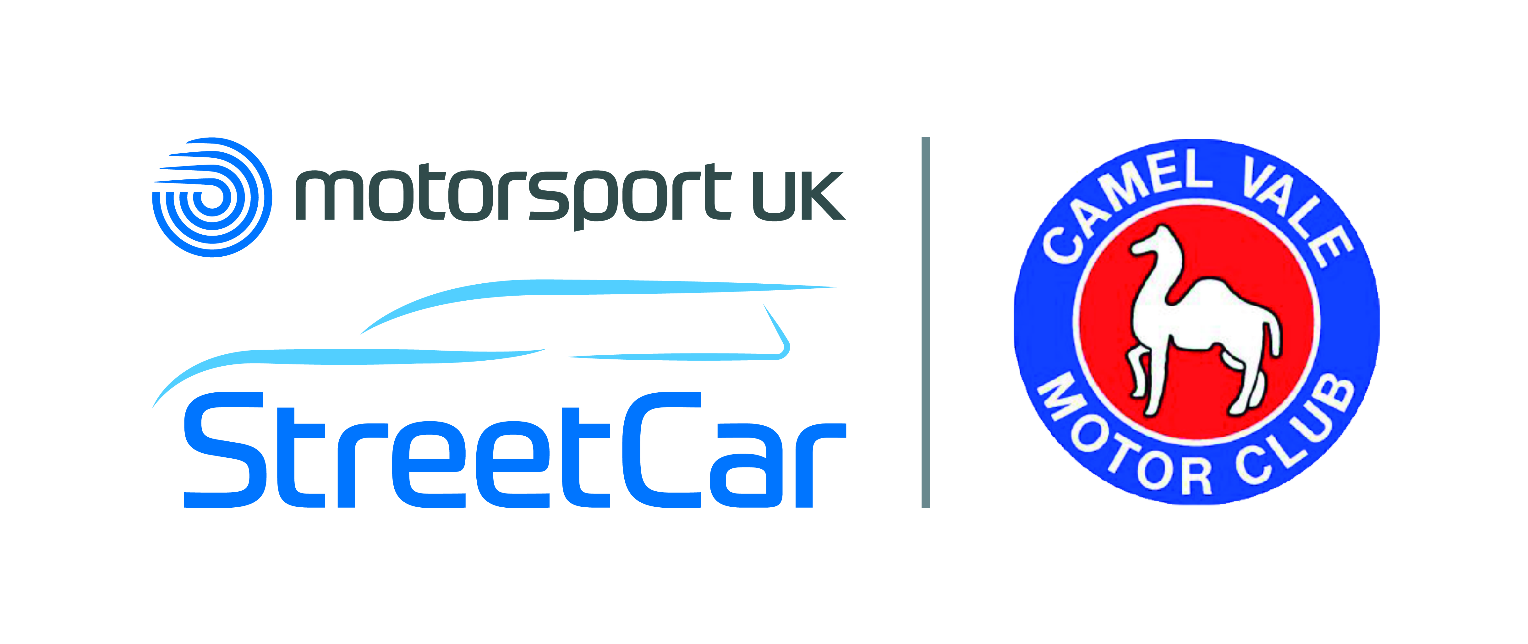

We are a recognised Street Car Club

- Camel Vale Motor Club Ltd will promote a grass field surface Production Car Autotest on Sunday 23rd July 2023 at Colquite Estate, Washaway, Bodmin, PL30 3AF. Entrance will be arrowed from the Washaway road.
- The meeting will be held under the General Regulations of Motorsport UK., (incorporating the provisions of the International Sporting Code of the FIA) and these Supplementary Regulations.
3. Motorsport UK Clubmans Permit - 131987
4. The event is open to all fully elected juniors (14-18 years of age) and over 18’s who have not previously competed in motorsport of the organising club,, Launceston & North Cornwall MC, Newquay AC, Truro & District MC, Plymouth MC, South Hams MC, Holsworthy MC, North Devon MC, Windwhistle MC, MG Car Club, Woolbridge MC
5. Competitors require a Club membership card and RS Clubmans Licence (as a minimum) which will be inspected at signing-on.
6. The event is a round of the 2023 CVMC South West Sweepers Autotest Championship, points awarded to club members , for CVMC Under 21 Trophy, CV Car Trophy, Brian Rabey Trophy, Grimshaw Shield.
7. The programme of the meeting will be:
Scrutineering from 11:00 hrs
First car starts at 11:30 hrs
Any car not signed on by 11:15 hrs may be excluded
Competitors will be given opportunity to walk the course prior to competing.
8. The event will consist of classes:
CLASS A Front engine, rear wheel drive production saloons, . Up to 2,000cc
CLASS B Production saloons with engine over driven wheels. Up to 2,000cc
All cars must comply with the current Motorsport UK vehicle and tyre regulations. Please note that “Knobbly” tyres are not permitted. M&S tyres are allowed provided they are the standard road tyre, not the knobbly ones, with NO SNOW SYMBOLS on them.
Note the following types of tyre are not permitted
Off road / Grip / Winter / Cross Climate / All-Season
9. Awards will be presented as follows:
Overall winner
Class win - subject to 3 starters in class
2nd in Class - subject to 5 starters in class
3rd in Class - subject to 9 starters in class
10. The entry fee is £20 per car if the entry is received by the Secretary prior to 5:30pm on Sunday 16th July,
thereafter the entry fee will be £25 Please enter using the online form on the club website.
Payment should be made by Bank Transfer to:
Account name Camel Vale Motor Club Ltd
Sort Code 30 – 98 – 98
Account number 38422460
Please use the following reference when paying by bank transfer - date of event and name of entrant, eg for somebody called Smith entering this event it would be 23/7Smith.
Entry fee will be refunded if notice of withdrawal is given in writing by the pre-closing date, an administration charge may be made after the pre-closing date.

11. The Entries Secretary is:
Michelle Cundy Tel: 07868 226764
Email: michellecundy4@gmail.com
Clerk of the Course Roy Hartley Other officials: TBA
12. The entry list opens on publication of these SRs The maximum entry for the meeting (AutoTest & PCA) is 30, the minimum is 6 Entries are accepted at the organiser’s discretion. The running order will be by reverse order of receipt of entry. Classes may be amalgamated or sub-divided at the organiser’s discretion. Cars may be double driven.
13. Details of tests and any final instructions will be issued at signing on. Drivers will be allowed a minimum two runs at each test all of which will count towards results. Cars will be identified by numbers supplied by the organisers. Timing will be by marshal’s hand held stopwatch. Timing will commence on verbal instruction of the marshal at the start of the test.
14. Any driver who does not hold a full RTA Licence may only drive a Touring Car (i.e. Series Production Car as
defined in the Motorsport UK YearBook) with a maximum engine capacity of 2000cc. Minimum age - 14 years.
A passenger must be carried who holds a RTA licence and must occupy the seat alongside the driver. No
other passengers are permitted. Properly fastened seat belts must be worn by both driver and passenger
15. As the event takes place wholly on private property, vehicles need not be taxed or registered
16 Results will be published in accordance with D26.1.3 (i.e. 7 days) although preliminary results may be available after the event
17. Any protest must be made in accordance with the Motorsport UK Yearbook 2023 Section C and accompanied by the appropriate fee.
18 Penalties
Wrong test / maximum score per test is: fastest time in running class plus 20 secs
Finish astride (failing to) - 5 seconds
Hitting cone / marker 5 secs
19 Any competitor / marshal under the age of 18 requires Parental Consent

