Camel Vale Motor Club Ltd.
CAMEL CLASSIC TRIAL 2023
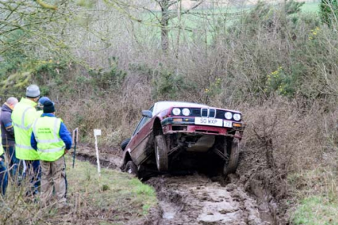
2022 Winner of the Dave Keat Trophy – Matt Facey

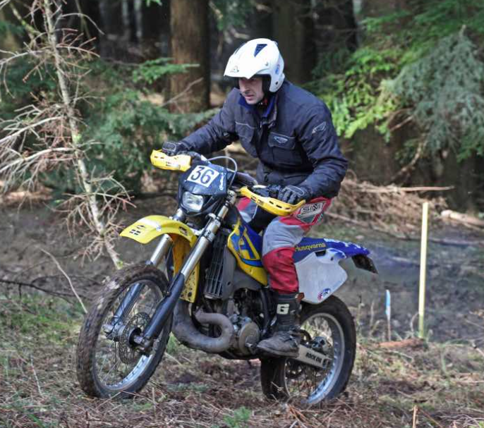
2022 Winner of the Wadham Stringer Trophy – Richard Maddern

INTRODUCTION

The Camel Classic Road Trial first ran in 1983 (called the Octo for the first two years) thanks to two new trialers Hans Viertel and Pete Allen. The event flourished every year and soon became a round of the Chester Motor Club Trials Championship and later ACTC and ASWMC Championship rounds. The original organising team of Hans and Pete were still running the event 31 years later in 2014.

Sadly Hans suddenly passed away in 2015 which was a huge loss to Camel Vale Motor Club and the trialling community. Hans was described by many as a true gentlemen and he is greatly missed by all. He really was totally immersed in trials; be it as a competitor, marshal or organising the Camel Classic in December every year. We hope his memory can live on in this event for many years to come.

For the first time ever in 2015 we invited motocycle solos and outfits to enter the trial. This was a success and all the riders enjoyed the event so we will continue this for future years.

Hope you enjoy the event!

CAMEL CLASSIC TRIAL – 3rd December 2023
SUPPLEMENTARY REGULATIONS

1. The Camel Vale Motor Club Limited will organise a Clubmans Permit Classic Reliability Trial on Sunday 3rd December 2023 starting at The Borough Arms, Dunmere, Bodmin, PL31 2RD. Map Ref: 200/048674

2. The meeting will be governed by the General Regulations of Motorsports UK (incorporating the provisions of the International Sporting Code of the FIA), these Supplementary Regulations and the National Sporting Code and Standing Regulations for trials of the ACU.

- Motorsport UK permit – 133224
DOE Authorisation – applied for.
ACU permit – applied for

- The event is open to fully elected members of the organising club and the following motor clubs Bristol MC, Holsworthy MC, Launceston & NC MC, MCC, Minehead MC, North Devon MC, Plymouth MC, Ross & DMC, South Hams MC, Stroud & DMC, Torbay MC, Truro & DMC, Windwhistle MC , Woolbridge MC. and registered contenders in the ACTC and ASWMC Classic Trials Championships

4a The motorcycle event is open to members of the ACU

5 All car competitors (driver and passenger) must produce a valid Club Membership Card, a Motorsport UK RS Clubmans Licence (as a minimum) and a current MOT certificate as applicable. Motorcycle entrants must produce their ACU Trials Registration membership card and motorcycle club membership card.
Passengers under 18 years of age will not be considered as competitors for the purpose of Licences and Club membership but will be required to sign on. Any competitor or passenger under the age of 18 will be required to produce a letter of consent from parent or guardian at signing on, which will be retained.

6. The event is a round of the ACTC Championship and the 2023 ASWMC Classic Reliability Trial Championship.

7. The programme of the meeting will be:
i) Scrutineering starts at 7.30.
ii) First competitor starts at 8.00am and the remainder at 2 minute intervals.
Any competitor not signed on 30 minutes before their start time may be excluded.

8. Public roads will be used to link sections. There will be at least 12 sections and 2 special tests. Details of sections/tests
will be issued at signing on. The route will be approximately 55 miles on OS Maps 200 & 201.

9. The car event will consist of eight classes as follows:
1) Front engine, front wheel drive production cars (including those fitted with torque biasing / limited slip differentials)
2) ‘Production Cars’ built prior to 1941 including post war cars as per current ACTC technical regulations
3) Front engine, rear wheel drive production saloons (except those vehicles in class 6)
4) Rear engine, rear wheel drive production saloons up to and including 1300cc (except those vehicles in class 7)
5) a) Front engine production sports cars (except those vehicles in classes 1 & 6)
b) Vehicles in full HST Historic Class specification with fiddle brakes disabled and Non-production cars built mainly
from pre-1941 components (except vehicles approved for class 2) as per current ACTC technical regulations
c) Non-production cars eligible for Class 2, but running on radial tyres
6) a) Rear engine, rear wheel drive production cars (except vehicles in class 4)
b) Front engine production cars fitted with torque biasing differentials as standard equipment
7) a) Production cars modified beyond permitted limits
b) Rear engine production cars fitted with torque biasing differentials as standard equipment
c) Front engine cars manufactured on a limited basis and conforming to accepted specification and listed. These cars
must comply with either or both of the following:
i) have the rearmost part of the front seat cushion(s) forward of any part of the rear tyres
ii) have a wheelbase of 90 inches (228.6cm) or greater.
8) a) Non-production cars
b) Rear engine cars (except those vehicles in classes 4, 6 & 7)
c) Front engine cars manufactured on a limited basis (except those vehicles in class 7) including those which
i) have the rearmost part of the front seat cushions(s) rearward of any part of the rear tyres
ii) have a wheelbase of less than 90 inches (228.6cm).
90) Suzuki X90’s running an original engine block

All vehicles must comply with the Motorsport UK or ACU Technical Regulations for Classic Trials. All vehicles must have effective silencing; any vehicles considered by the Scrutineers to be too noisy will not be allowed to start. Noise checks may be in operation during the event.

The motorcycle event will consist of the following classes:
The event will consist of the following classes:
Class A: Solo motorcycles with pre-1970 derived frames and engines.
Class B1: Solo motorcycles up to 225cc (except vehicles in Class A)
Class B2: Solo motorcycles over 225cc and up to 450cc
Class B3: Solo motorcycles not eligible for Classes B1 & B2. These are: Honda/Montesa 4Ride, TRRS XTrack, Ossa Explorer, GasGas Randonne, GasGas Connect, Scorpa LongRide & Honda TRL
Class C: Solo motorcycles over 450cc
Class D1: Motorcycles with sidecars (to trials spec, as defined in ACU Trials regulations)
Class D2: Motorcycles with sidecars (enduro/motocross derived frames, with or without nosecones)
Class E: Three-wheelers (See Appendix)
Class X: Motorcycles which do not comply with Classes A-D, running for honours only

All tyres must comply with ACTC or ACU regulations as appropriate.

10. The Awards will be presented as follows:
The Dave Keat Trophy to be held for 11 months and replica to the best performance in car classes on Index of Performance.
The Wadham Stringer Trophy to be held for 11 months and replica to the best performance in motorcycle classes.
The Jon Kessell Award for the best performance by Camel Vale Member (entered under Camel Vale in their entry form) to be held for 11 months plus replica (car classes only – calculated by Index of Performance).
Class Awards to the winner of each class except for overall winners subject to 3 starters in class
Second in Class awards subject to 5 starters in class
Third in Class awards subject to 9 starters in class
Novice Award subject to 3 novice starters, on class index.
Best Lady - an award subject to 3 lady starters, on class index
Points will be awarded from the car classes towards the Camel Vale Bridge Garage Trials Trophy, the Camel Vale Car Trophy and the Vernon Perry Memorial Trophy, and the award for the best Under 21 year old to be awarded annually.
The Historic Motor Sport Trophy will be awarded to the person who helped the organisers the most in running the event.

11. The entry list opens on 18th Oct 2023 and CLOSES FINALLY ON FRIDAY 24th NOVEMBER. The entry fee for cars, solo motorcycles, outfits and 3 wheelers is £45.00. All entries must be made on the official entry form or using the online form and accompanied by the appropriate fee. Please enclose 2 x C5 SAE envelopes, 1ST Class, for final instructions and results if you don’t wish to have them sent via email.
Payment by Bank Transfer to Account Camel Vale Motor Club Ltd Sort Code 30 98 98 Account Number 38422460
Or if paying by cheque please add £1 to cover bank charges. Cheques payable to “Camel Vale Motor Club Ltd”.
Please use the following reference when paying by bank transfer - date of event and name of entrant, eg for somebody called Smith entering this event it would be 3/12Smith.

12. The secretary of the meeting to whom all entries must be sent is:
IAN CUNDY, 111 STATION ROAD, ST BLAZEY, PAR, CORNWALL, PL24 2LZ.
TEL. 07475 109745. Email: cundyian@gmail.com

13. The maximum entry for the meeting, including reserves is 80, split cars 50 and motorcycles 30. The minimum is 25. The minimum for each class is 3. Should any of the minimum figures not be reached, the organisers have the right to cancel the meeting or amalgamate the classes as necessary. Entries will be selected by random draw within each class. Entry fees may be partially refunded at organiser’s discretion, if notified by Friday 24th November 2023.

14. Other officials are:
Stewards: TBA (cars) TBA (motorcycles)
Clerk of the Course: Pete Allen (Cars) TBA (motorcycles)
Secretary: Ian Cundy
Scrutineer: TBA
Chief Marshal: TBA

15. Any protest must be lodged in accordance with the 2023 Motorsport UK 'Blue Book' and ACU regulations and sporting code.

16. Provisional results will be published as soon as possible following the end of the event.

17. Competitors will be identified by numbers which will be issued at the start and must be removed at the finish or upon retirement.

18. Practising will not be allowed at any time and any competitor found doing so will be excluded.

19. Marking and penalties will be as printed in the appropriate section of the Motorsport UK General Regulations. All other General Regulations of Motorsport UK apply as written. Motorcycles will be marked as follows- a stop or footing will constitute a failure at that point in the section. Footing will however be allowed for the first 3 yards in a section. Sections will be sub-divided 12 – 1. Hitting markers is allowed on sections but not markers for restarts or on special tests, unless otherwise stated in the route card or final instructions. Some sections will have re-starts for selected classes. In the event of a tie in any class, aggregate times on Observed Special Tests will decide, should a tie still exist, test 1 will decide, with the smallest cc engine having preference should a further tie exist.

20. It is the competitors responsibility to ensure they have appropriate insurance, road tax and a mot where applicable. There will be no official lunch halt. The finish will be at THE BOROUGH ARMS, DUNMERE, BODMIN approximately 0.5 from Bodmin on the A389 towards Wadebridge. (Map Ref: 200 048674). Refreshments will be available at the finish where competitors must sign off to receive a Finishers Certificate. Petrol, Oil, etc. will be available near the start and once on route at the services near Victoria. Competitors can leave trailers at the start/finish venue. Route cards will be issued at the start.

21. A minimum tyre pressure may be imposed by class or by section as announced on the route card.

22. Competitors will run in class order and must as far as possible remain in numerical order throughout the event.
The classes will run in the following order:
D2, D1, E, A, B1, B2, B3, C, E, X, 1, 2, 3, 4, 90, 5, 6, 7, 8

23. No vehicles will be allowed to carry any advertising material except for club or championship decals up to a maximum of 55 sq. in. Competitors are reminded that advertisements covered by paper and/or tape are not acceptable. Any vehicle whose appearance or condition is below standard appropriate to the event will not be allowed to start. All cars must carry a small spill kit and fire extinguisher to Q3.1.1.

24. It is vital that competitor’s cars must be capable of having a tow rope quickly and firmly fitted. This must be of sufficient strength to withstand the snatch of a tow from a recovery vehicle.

25. INSURANCE
Insurance must be valid for this type of event. The Club have applied for a Blanket Certificate of Insurance under the REIS Road Section Scheme. This will provide competitors who need to use the Scheme to obtain Third Party cover to meet RTA requirements. The Basic Rate for the Event (before any loadings) will be £17.50.
Applicants wishing to use the Scheme must be able to comply with all the points of the REIS Declaration:-
Age 19 years or over. Has held a full licence for a minimum of 6 months. Has no more than 6 points on their licenceHas had no more than 1 fault claim in the last 3 years. The vehicle must hold a valid MOT Cert, current road insurance, and Road Tax, unless exempt from doing so. All competitors MUST be a named driver on the road insurance
If able to comply with all above points above, simply sign on Signing On Forms for insurance at the start No letter of acceptance will be issued. If unable to comply with any of the above points then a declaration form must be obtained direct from REIS to obtain acceptance to the scheme well in advance.

26. Any competitor overtaken by a back- marker will be deemed to have retired.

27. Any competitor involved in an accident must make a written report to the Secretary at the finish or within 7 days of the event if a non-finisher.

28. Entries will not be acknowledged before posting Final Instructions (27th November 2023) unless entrant encloses an additional SAE with their entry and request acknowledgement or provide an email address on the entry form.

29. Any offers of marshalling would be greatly appreciated so please contact Ian Cundy on 07475 109745 (please leave a message) or at cundyian@gmail.com

30. NO MUDDY BOOTS OR SHOES PLEASE (carry a clean pair for use at the finish).

31. Details of overnight accommodation can be supplied by contacting the secretary.

Previous Winners
Dave Keat Award/ Lubetech Trophy/
Wadham Stringer Trophy John Kessell Award
(Overall) (Best Camel Vale Member)
1983 Roger Hancock --------------
1984 John Clarkson Lester Keat
1985 John Clarkson Steve Ball
1986 Richard Penhale Roy Bray
1987 Steve Ball Dave Keat
1988 Roger Hancock Jon Robilliard
1989 Roy Malin Jon Robilliard
1990 Roger Hancock Adrian Ball
1991 Graham Watton Roger Hancock
1992 Jon Robilliard Roger Hancock
1993 Dean Vowden Jon Robilliard
1994 Jon Robilliard Roger Hancock
1995 Jon Robilliard Roger Hancock
1996 Clive Kalber Roger Bricknell
1997 Martyn Harry Roger Hancock
1998 Adrian Dommett Martyn Harry
1999 Paul Bartleman Jon Robilliard
2000 Nigel Allen Ian Cundy
2001 ------------- Did not run --------------
2002 Nigel Allen Roger Bricknell
2003 Paul Bartleman Andrew Martin
2004 Paul Bartleman David Haizelden
2005 Paul Bartleman Ian Cundy
2006 Adrian Marfell Dick Bolt
2007 Emma Robilliard Andrew Rippon
2008 Tony Young Tristan White
2009 Paul Bartleman Alan Keat
2010 Paul Bartleman Dick Bolt
2011 Ian Moss Andrew Rippon
2012 Adrian Marfell Ben Gladwyn
2013 Keith Sanders Lester Keat
2014 Keith Sanders Andrew Rippon
2015 David Haizelden James Shallcross
2016 Keith Sanders Simon Groves
2017 Aaron Haizelden Roger Hancock
----------------------------------------------------------------------------------------------------------------
Dave Keat Trophy John Kessell Award Wadham Stringer Trophy
2018 Adrian Marfell Dan Keat Alan Keat
2019 Stuart Bartlett Aaron Haizelden Chris Dustow
2020 Did not run
2021 Did not run
2022 Matt Facey James Shallcross Richard Maddern

